Job Assignment Template

- Enter the ID#, First Name, Last Name and Job Name as you normally would. Job Name must match the name in RE exactly.
- The Job Category column contains a drop down list to select the correct category. As soon as you select your category the Volunteer Type column will populate with the corresponding volunteer type. NOTE: The Job Category HAS to match the category of the job in RE. Be sure to check that prior to entering the info.
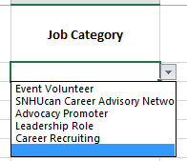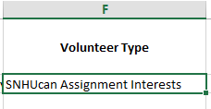
- Enter the Start Date. The date format must be xx/xx/xxxx.
- Enter an Interest/Attribute from the drop down list. This will only show the interests/attributes that correspond to the Job Category that you selected. If you’re not sure leave this field blank.
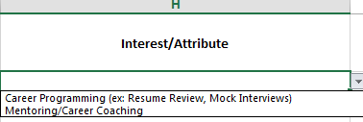
- Enter the End Date (format xx/xx/xxxx) and Hours.
- Select Yes, No or Already Acknowledged in the next column.
- Enter your initials in the Submitted by column.
- The Job Assignment Notes column is for any special notes about this volunteer that we may need to know.
- The Miscellaneous Notes column is for notes specifically for Jerri Clayton pertaining to employment info etc.
- Enter a LinkedIn URL if available.
- When complete, perform a Save As and give your spreadsheet a new name. This will preserve the template file. If you do accidentally save over the template please contact me (l.folger@snhu.edu) and I can email you a new one.

